Project Design Phase-I
Problem – Solution Fit Template

Date | 28 October 2026
Team ID | Individual Project - Ujjawal Rathod
Project Name | Electric Vehicle Market Performance & Insights
Maximum Marks | 2 Marks

Problem – Solution Fit Template:
The Problem-Solution Fit simply means that you have found a problem with your customer and that the solution you have realized for it actually solves the customer’s problem. It helps entrepreneurs, marketers and corporate innovators identify behavioral patterns and recognize what would work and why
Purpose:
- Solve complex problems in a way that fits the state of your customers.
- Succeed faster and increase your solution adoption by tapping into existing mediums and channels of behavior.
- Sharpen your communication and marketing strategy with the right triggers and messaging.
- Increase touch-points with your company by finding the right problem-behavior fit and building trust by solving frequent annoyances, or urgent or costly problems.
- Understand the existing situation in order to improve it for your target group.

Template:
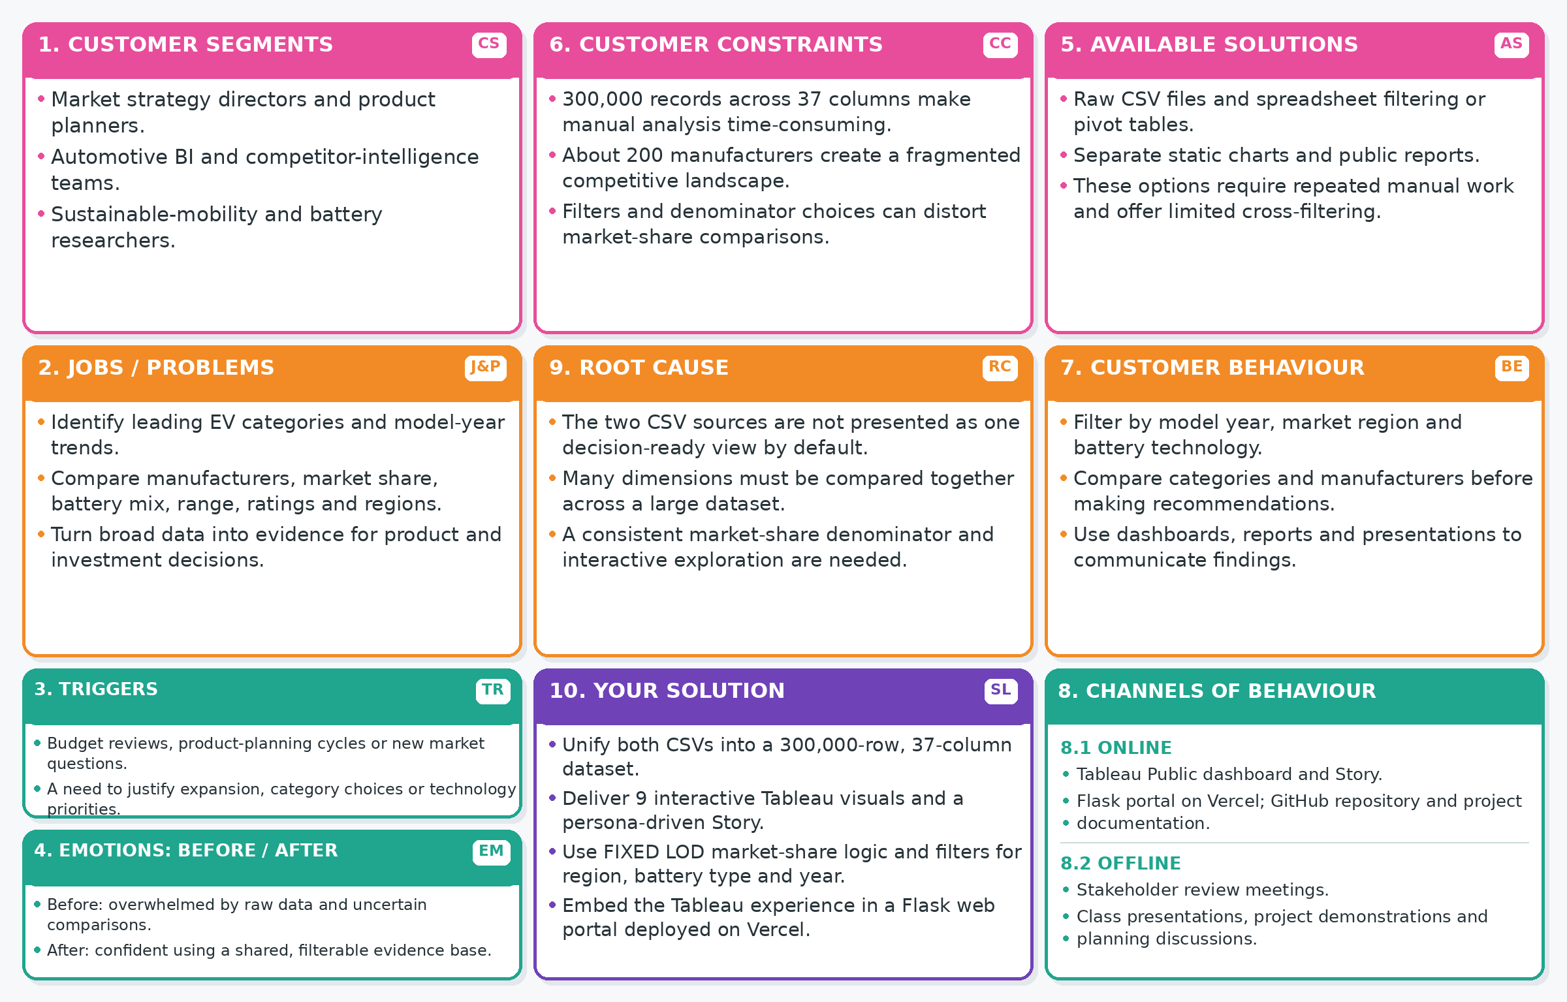
References:
- https://www.ideahackers.network/problem-solution-fit-canvas/
- https://medium.com/@epicantus/problem-solution-fit-canvas-aa3dd59cb4fe
Completed Problem-Solution Fit Canvas
Project-specific details expanded from the canvas on the previous page for easier reading.
Canvas element | Project-specific content
1. Customer segments | Market strategy directors and product planners; automotive BI and competitor-intelligence teams; sustainable-mobility and battery researchers.
2. Jobs-to-be-done / problems | Identify leading EV categories and model-year trends; compare manufacturers, market share, battery mix, driving range, customer ratings and regional patterns; turn large datasets into evidence for decisions.
3. Triggers | Budget and portfolio reviews, product-planning cycles, market expansion questions, or requests to justify category and battery-technology priorities.
4. Emotions: before / after | Before: overwhelmed by raw spreadsheets and unsure how to compare segments consistently. After: more confident because key measures and trends are available in a shared, interactive view.
5. Available solutions | Raw CSV files, spreadsheet filters and pivot tables, separate static charts, and public reports. These approaches often require repeated manual work and offer limited coordinated cross-filtering.
6. Customer constraints | The dataset contains about 300,000 records and 37 columns; the market includes about 200 manufacturers; comparison quality depends on consistent field definitions, filter behavior and market-share denominators.
7. Behaviour | Users explore model years, market regions and battery types; compare categories and manufacturers; and use dashboards, reports and presentations to explain findings and recommendations.
8. Channels of behaviour | Online: Tableau Public dashboard and Story, Flask portal deployed on Vercel, GitHub repository and project documentation. Offline: stakeholder review meetings, class presentations, project demonstrations and planning discussions.
9. Problem root cause | The two CSV sources need to be brought into a common analysis view; multiple dimensions must be compared together; and static reporting can hide the effect of filters or inconsistent denominator logic.
10. Your solution | Combine the two CSV sources into a 300,000-row, 37-column dataset; present nine interactive Tableau visualizations and a persona-driven Story; apply FIXED LOD market-share logic; provide region, battery-type and model-year filters; and embed the Tableau experience in a Flask web portal deployed on Vercel.

